**What factors predict security incidents in the Portland Metro Area Public Transit System?**

**ABSTRACT**

This study addresses unpleasant and unsafe conditions experienced by passengers and operators of public transit in Multnomah, Clackamas, and Washington counties. There were 54% more security incidents in 2022 compared to 2019. By analyzing TriMet's security data, we aim to identify the key factors contributing to these incidents, such as neighborhood, time of day, and route. The ultimate goal is to provide actionable recommendations to TriMet to enhance public transit safety and reliability for all stakeholders. TriMet, the Tri-County Metropolitan Transportation District of Oregon, is a significant public agency responsible for operating mass transit in the Portland metropolitan area. The analysis will examine TriMet's security data to identify patterns and correlations between incidents and specific factors. Based on these findings, we will propose practical strategies to improve safety and reliability, benefiting passengers and operators. This research has the potential to contribute to the broader transportation industry by offering data-driven insights into how public transit systems can address safety concerns effectively.

**CONTEXT**

**What is the problem?**

The problem at hand is the imperative to enhance safety and security in TriMet's public transit system. Recent high-profile crimes have caused alarm among state leaders and riders, highlighting the pressing need for improved security measures. The prevalence of unpleasant and unsafe conditions experienced by passengers and operators is detrimental to their overall transit experience and can discourage ridership. Addressing this problem is not only about the continuity of the agency and preventing crime but also about fostering an environment where passengers can feel at ease and confident while utilizing public transportation.

**Why is it important to solve?**

This is a critical problem to solve for several reasons. The first reason is Passenger Safety - Ensuring the safety of passengers is of the utmost importance for any public transit system. By identifying and addressing the key factors contributing to these unfavorable conditions, TriMet can take proactive measures to enhance passenger safety and reduce the risk of incidents that will, in turn, provide a more secure and reliable transit experience. Another critical reason is Public Confidence - Addressing safety concerns and improving overall safety in public transit can increase public confidence in the system. When passengers feel safe and secure, they are more likely to use public transit, increasing ridership and reducing reliance on private vehicles. A safe and welcoming public transit system is critical for repairing Portland's reputation as a global destination for tourism, recreation, and business opportunities. Our final reason is Operational Efficiency - Analyzing the key factors contributing to incidents can help TriMet optimize its operations. By understanding when and where incidents are more likely to occur, they can allocate resources more effectively, implement targeted security measures, and optimize service routes and schedules. Solving this problem is vital as it contributes to the well-being of the general public who uses the public transit system and improves the overall efficiency of TriMet's operations, leading to a safer and more reliable public transit system.

**PROPOSAL**

After conducting further research and engaging in discussions, we have refined our research question to focus on predicting security incidents in the Portland Metro Area Public Transit System. The revised outline for our capstone project is as follows:

**I. Introduction**

A. Background and significance of the research topic

B. Objective of the capstone project

**II. Literature Review**

A. Overview of previous studies on security incidents in public transit systems

B. Analysis of relevant research on factors influencing security incidents

C. Identification of gaps or limitations in the existing literature

**III. Data Collection and Preprocessing**

A. Description of TriMet's historical security data

B. Methodology and sources for data collection

C. Preprocessing steps, including data cleaning, handling missing values, and formatting

**IV. Descriptive Analysis of Security Incidents**

A. Summary statistics of security incidents in the Portland Transit System

B. Temporal analysis of incident trends and patterns

C. Geospatial analysis to identify incident hotspots

D. Categorization of incidents based on severity or type

**V. Predictive Modeling**

A. Selection of appropriate machine learning algorithms for incident prediction, specifically focusing on subtype incidents

B. Feature engineering and selection techniques

C. Training and evaluation of predictive models

D. Comparison of model performance and identification of key predictors

**VI. Factors Influencing Security Incidents**

A. Identification of potential factors impacting security incidents (e.g., time of day, location, route type)

B. Correlation analysis to determine relationships between factors and incidents

C. Exploration of external factors (e.g., weather, events) and their influence on security incidents

**VII. Interpretation and Insights**

A. Interpretation of findings from the analysis

B. Identification of significant factors influencing security incidents

C. Insights into potential strategies for mitigating security incidents in the Portland Transit System

**VIII. Conclusion and Future Work**

A. Summary of the key findings and contributions of the capstone project

B. Limitations and potential directions for future research

**IX. References**

A. List of cited works and resources used during the capstone project

This revised outline provides a structured framework to explore and analyze factors that predict security incidents in the Portland Metro Area Public Transit System, leading to valuable insights and potential strategies for enhancing security measures.

**How we plan to answer:**

Our research aims to identify factors that can predict security incidents in the Portland Metro Area Public Transit System at a high-level. To begin, we examined the most common types of crimes in 2022 and conducted a detailed analysis of the predominant terms used in the descriptions of security incidents. Furthermore, our study delves into the impact of crime on various modes of mass transportation within the mass transit categories.

The analysis encompasses crime incidents related to the Portland Metro Transit system from January 2017 to June 2023. Given the significant 54% increase observed in 2022, we narrowed our focus to that particular year. The dataset comprises approximately 17,000 recorded security incidents, including offenses such as larceny, vandalism, motor vehicle theft, burglary, and more. The individual-level data includes details on crime type, event descriptions provided by security personnel, timestamps, and locations. However, accurately displaying latitude and longitude coordinates presents a significant challenge.

Additionally, we face the obstacle of classifying around 14,000 data points that are currently categorized as "other." To overcome this, we are utilizing the text comment column to classify each incident. Our current approach involves experimenting with supervised methods using labeled data and unsupervised methods applying PCA analysis to the entire dataset.

While we continue to gather data on safety incidents, security measures, and rider surveys from TriMet and other validated sources, we are also conducting interviews and surveys to engage with TriMet officials and gain insights into the existing security enforcement measures for protecting riders and employees. After analyzing the data and evaluating the current security measures in place, we plan to explore post-pandemic adaptation, considering potential outliers influenced by the changing economic conditions.

**What we hope to find:**

Our analysis aims to find efficient data on rider satisfaction, allowing us to assess how individuals perceive their overall safety and experience while using TriMet. This data will provide valuable insights into whether people feel unsafe or discouraged when utilizing public transit, as well as the percentage of riders who share these sentiments. Furthermore, we will examine TriMet's current security and protection measures to evaluate their effectiveness in preventing crimes. Additionally, we will explore the correlation between security issues on mass transit and the city's housing/mental health crises. This investigation entails gathering data from relevant agencies to assess whether a relationship exists between these factors and if one contributes to the increase in security issues on public transit. Through the gathering and analysis of this information, we can obtain a comprehensive understanding of the safety and security concerns associated with TriMet, evaluate the effectiveness of current measures, and identify potential areas for improvement.

**What we found:**

In our initial analysis, we examined the annual count of security incidents starting from the year 2017. This examination enabled us to uncover a significant finding: there was a substantial increase of 54% in the number of security incidents reported in 2022 when compared to 2019.

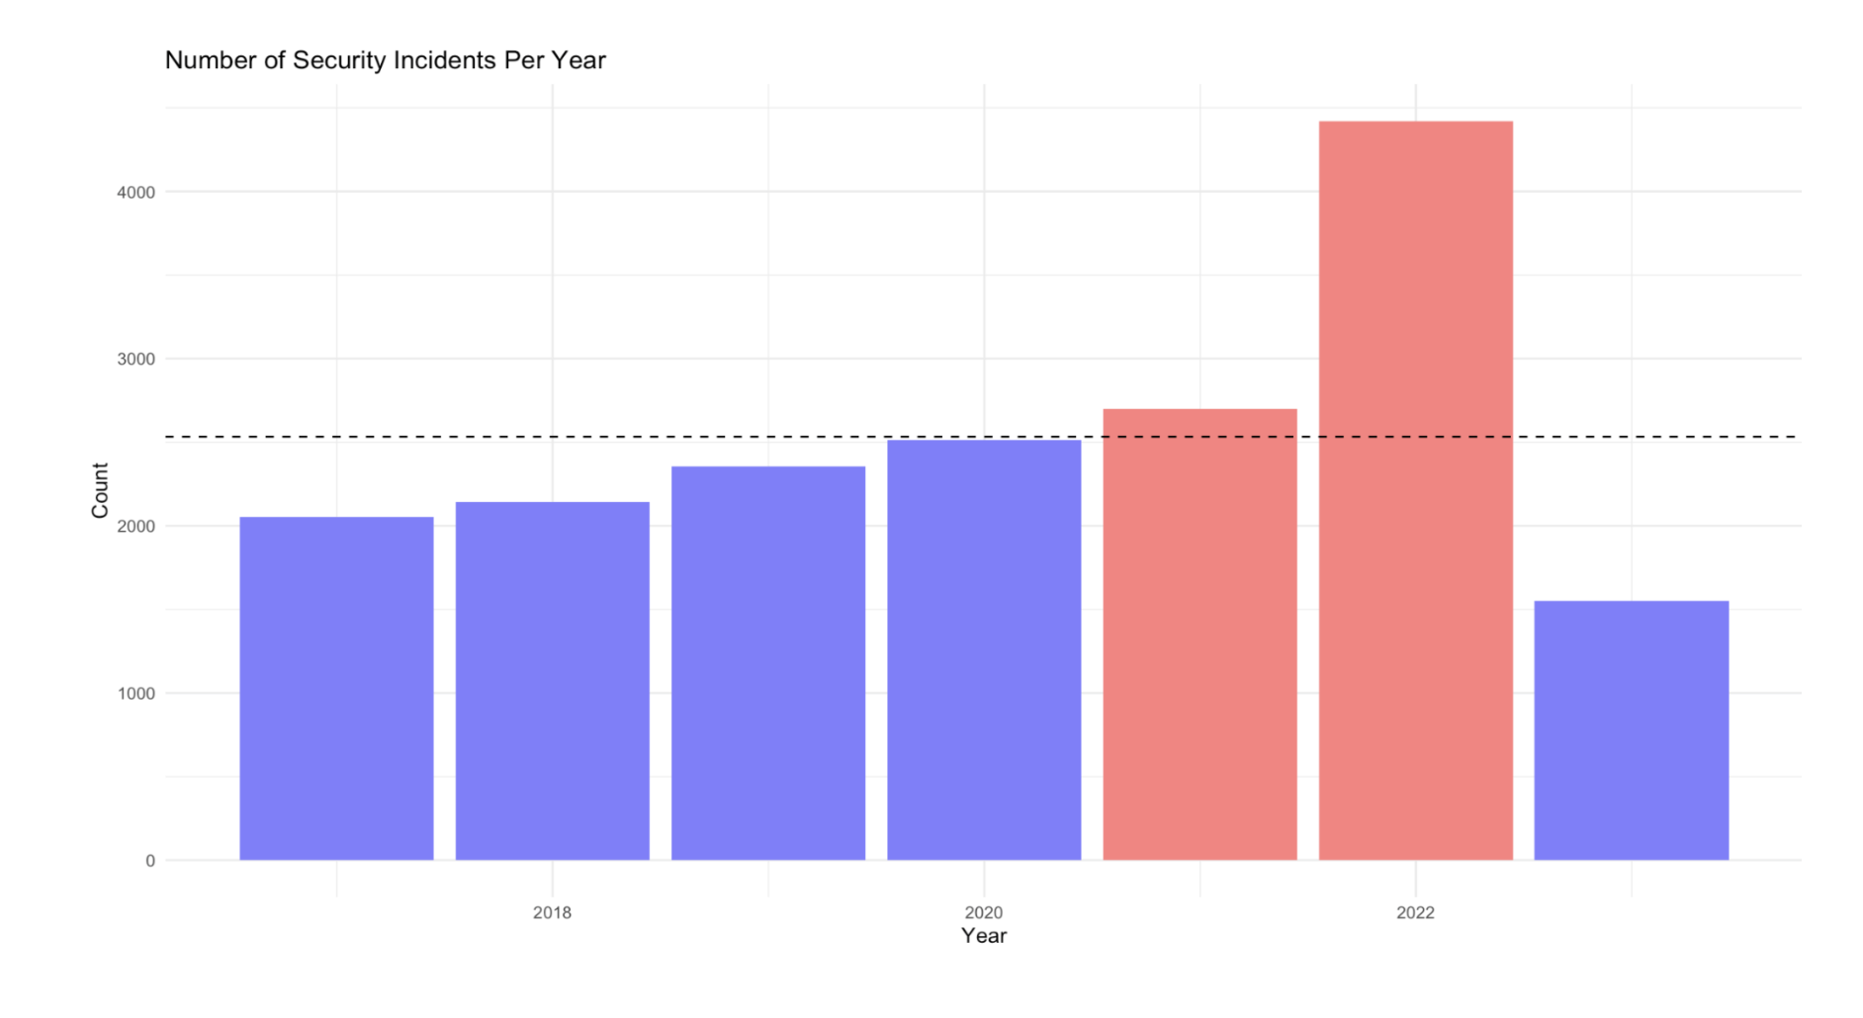

This analysis of security incident trends across multiple years provides valuable insights into the changing nature and magnitude of security risks faced by the organization. It serves as a call to action, prompting a reassessment of security protocols, allocation of resources, and the implementation of robust security strategies to ensure the protection of sensitive data and assets. In our analysis, we observed a significant increase in security incidents during 2022 compared to previous years. To gain further insights, we conducted a more detailed examination of the temporal patterns and discovered that the incidents were particularly elevated during the winter months. This finding led us to hypothesize that homelessness played a significant role, as individuals sought warmth and refuge on public transit systems, inadvertently contributing to increased criminal activities.

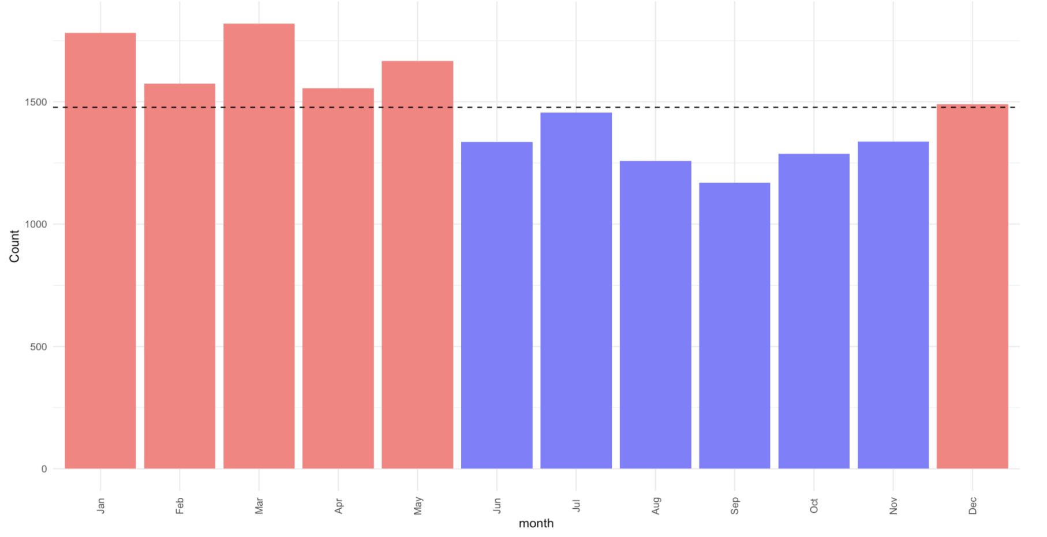

Recognizing this correlation between the winter season, higher TriMet incidents, and homelessness provides crucial information for addressing the issue comprehensively. It enables us to develop targeted interventions that enhance security measures while simultaneously providing support and resources for homeless individuals.

During our analysis, we scrutinized the incidents based on the day of the month and discovered an intriguing pattern. With the exception of the exact middle and latter part of the month, there were no significant trends in incident occurrence. These two distinct periods didn’t exhibit a noteworthy decrease in reported incidents, relieving further investigation into the underlying factors responsible for this pattern.

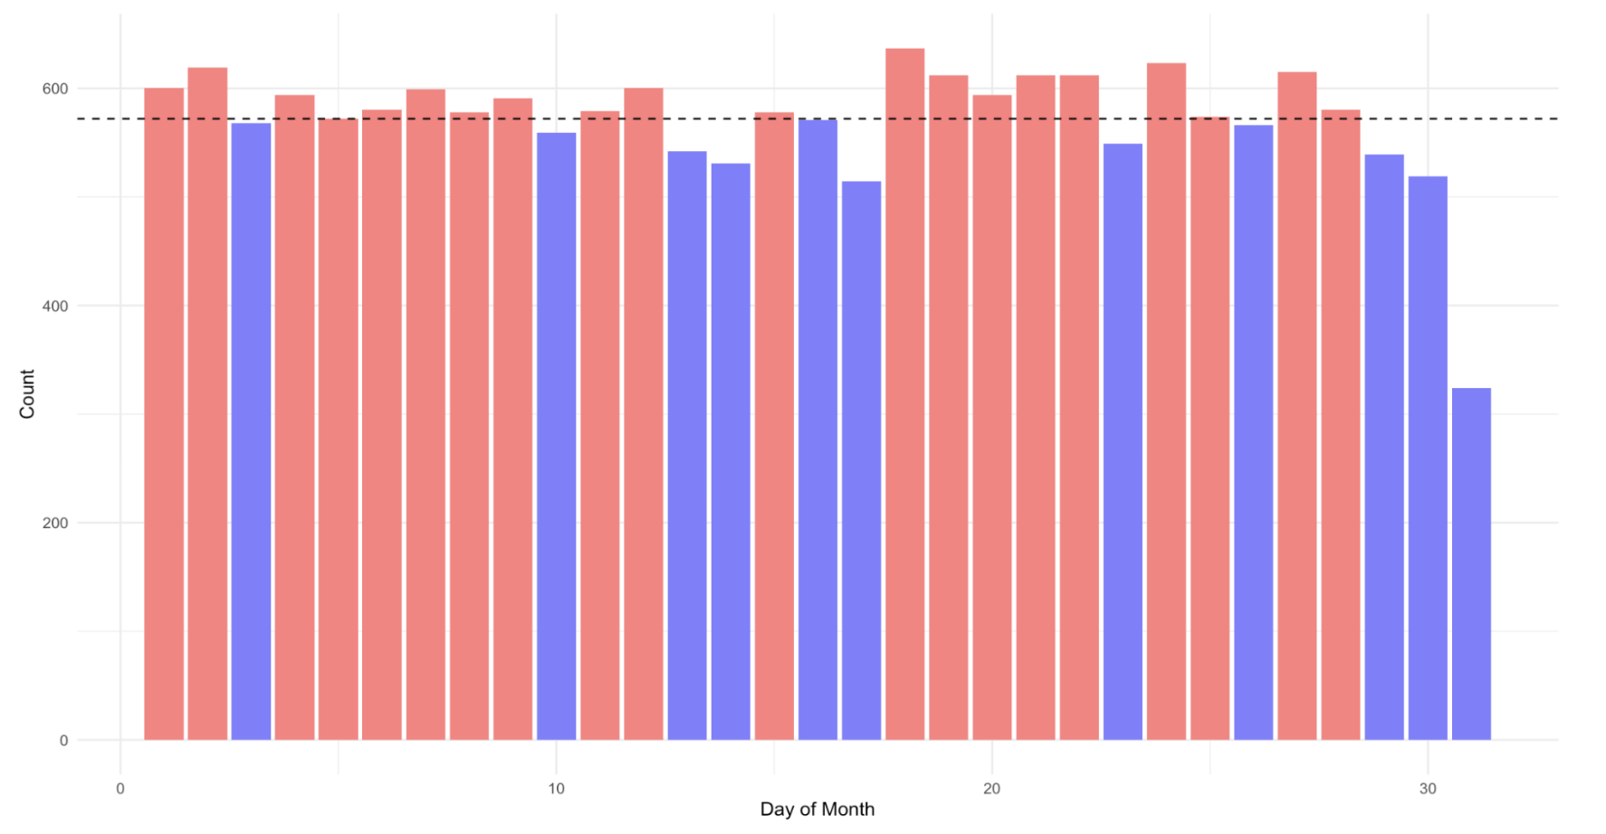

Understanding the reasons behind these temporal patterns can inform resource allocation, security measures, and incident prevention strategies. By identifying these specific time frames with reduced incident rates, organizations can proactively address vulnerabilities during other periods of the time of day. This knowledge also presents an opportunity to examine and replicate the practices or circumstances contributing to the decreased incidents, facilitating the design of more effective security strategies and creating a safer environment throughout the entire month. The analysis clearly demonstrates that a significant number of incidents occur during two distinct time periods: 6 AM to 12 PM and 3 PM to 12 AM. This pattern aligns with the commuting and transportation usage patterns of individuals, as many people utilize these services during the morning rush hour before work or school, as well as after work or school. The higher volume of passengers and the potential stress associated with commuting during these times may contribute to an increased likelihood of incidents.

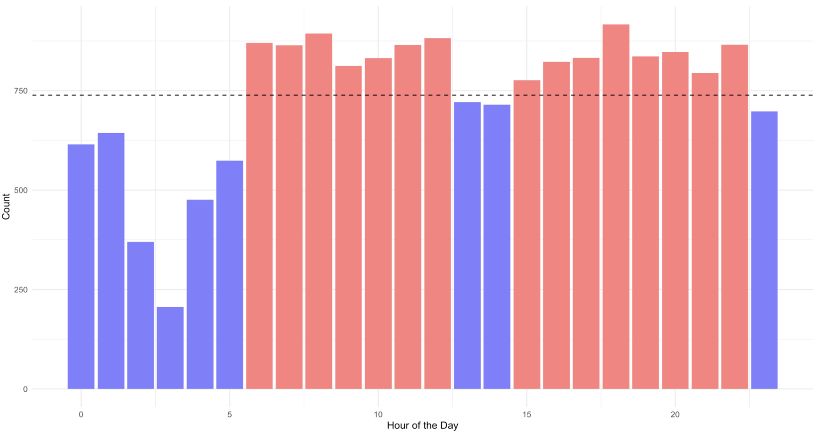

Recognizing this temporal concentration of incidents provides valuable insights for implementing targeted interventions to enhance safety and security. By deploying appropriate security measures, increasing staff presence, and raising awareness during these peak hours, transportation authorities can address the unique challenges and risks present during these specific time frames. Taking proactive steps to ensure the well-being of commuters and passengers during these high-activity periods is crucial in creating a safer and more secure transportation environment. Our in-depth analysis of crime types over the past three years revealed several significant findings. Firstly, vandalism consistently emerged as the most prevalent crime throughout this period, indicating an ongoing challenge in maintaining public property and preventing deliberate acts of damage. Secondly, motor vehicle theft consistently ranked as the second most frequent crime over the past two years, highlighting the persistence of this criminal activity. Lastly, theft from motor vehicles consistently occupied the third position, underscoring the recurring issue of targeted thefts within vehicles.

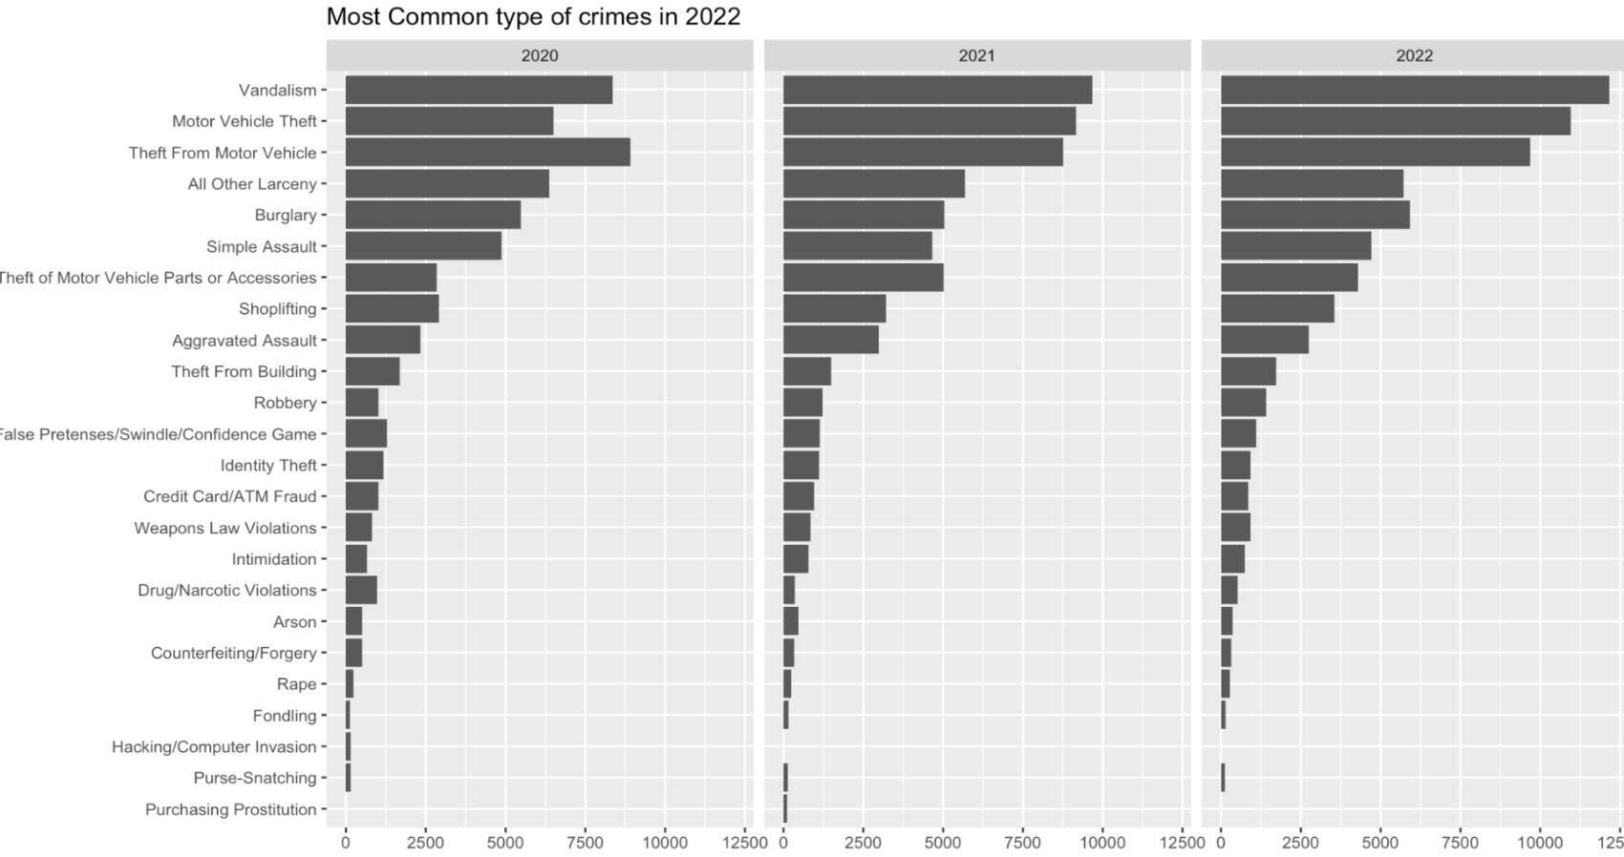

These findings emphasize the need for targeted interventions and preventive measures to address the persistent patterns of vandalism, motor vehicle theft, and theft from motor vehicles. Implementing robust surveillance systems, increasing security measures in vulnerable areas, and promoting community awareness campaigns can play crucial roles in deterring these crimes. By addressing these ongoing challenges head-on, law enforcement agencies and communities can work together to create safer environments, protect public and private property, and reduce instances of vandalism and theft.

During our analysis of security incident descriptions, we identified three standout keywords: "train," "police," and "notification." The term "train" suggests a notable association between incidents and public transportation, specifically the train system, emphasizing the need to address security concerns within this mode of transport. Enhancing surveillance, increasing personnel presence, and implementing awareness campaigns can help ensure the safety of passengers during their transit.

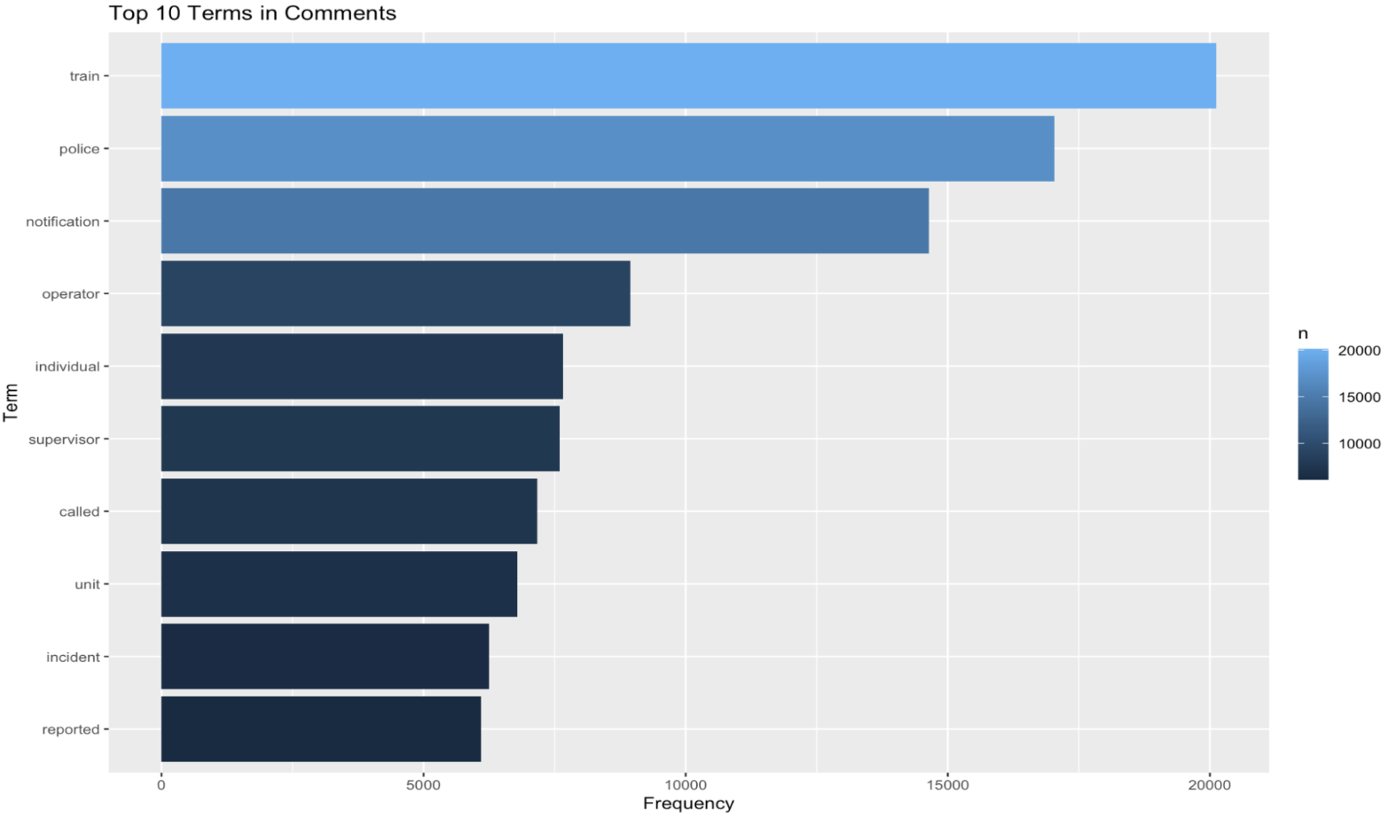

The presence of the keyword "police" highlights the involvement and response of law enforcement agencies in addressing reported incidents. Collaboration between transportation authorities and law enforcement becomes crucial in effectively addressing security challenges, leading to improved incident response, swift investigations, and overall enhanced security measures. Additionally, the recurring keyword "notification" underscores the importance of timely and effective communication with passengers and stakeholders. Implementing efficient notification systems that promptly alert individuals to potential risks enables them to take necessary precautions and make informed decisions regarding their safety. By recognizing the significance of these keywords, transportation authorities can prioritize their efforts in addressing train-related security incidents, fostering collaboration with law enforcement, and improving notification systems. These insights pave the way for targeted strategies aimed at creating a safer and more secure environment for passengers while traveling on trains.

**CONCLUSION**

**Summarize Problem & Solution:**

**Problem:** Passengers and operators of public transit in Multnomah, Clackamas, and Washington counties experience unpleasant and unsafe conditions. TriMet’s security data needs to be analyzed to identify the key factors contributing to these incidents.The goal is to provide actionable recommendations to TriMet to enhance public transit safety and reliability for all stakeholders.

**Solution**: In order to tackle the problem at hand, our approach involves collecting comprehensive data on safety incidents, security measures, and rider surveys from various validated sources, with a primary focus on TriMet. This data collection process includes leveraging information from the Portland Police Bureau and other relevant sources to ensure a robust dataset.

The gathered data will be subjected to thorough analysis to identify the key factors that contribute to unpleasant and unsafe conditions within the Portland Metro Area Public Transit System. These factors will include variables such as incident location, time of day, specific routes, and other relevant variables, including information about the officers present at the scene. By examining these factors, we aim to uncover patterns and correlations that shed light on the causes of safety incidents.

To gauge rider satisfaction and perceptions of safety, we will conduct surveys among passengers. These surveys will help assess the percentage of passengers who feel unsafe or discouraged while using the public transit system. By analyzing the survey responses, we will gain valuable insights into the specific areas and aspects that need improvement to enhance passenger safety and confidence.

Additionally, our analysis will evaluate the effectiveness of existing security measures implemented by TriMet, such as surveillance systems, police presence, and lighting. By assessing the impact and efficiency of these measures, we can provide evidence-based recommendations for potential enhancements or adjustments. Furthermore, our analysis will take into account the post-pandemic adaptation and its potential influence on safety incidents. We will also explore correlations between housing and mental health crises and their impact on public transit safety.

Based on the comprehensive analysis of the data, including incident records, rider surveys, and security measures, we will develop actionable recommendations tailored to TriMet. These recommendations will aim to improve public transit safety, enhance public confidence in the system, optimize operational procedures, and contribute to the creation of sustainable urban environments.

Overall, our approach combines data-driven analysis, rider feedback, and evaluation of current security measures to generate practical suggestions for TriMet, with the ultimate goal of fostering a safer and more reliable public transit experience for the community.

**How can the solution be important beyond the specific context, can it be generalized?**

The proposed solution of analyzing TriMet’s data to enhance public transit safety and reliability can be generalized beyond the specific context. By adopting a data-driven approach, evaluating security measures, assessing rider satisfaction, and providing recommendations, this solution can be applied to other public transit systems worldwide. The universal concerns of public transit safety, sustainable transportation, and the correlation between security issues and social factors make this approach relevant and valuable in diverse urban environments. Implementing similar strategies can improve safety measures, enhance the passenger experience, and contribute to developing efficient and sustainable public transit systems globally.

**Discuss limitations and potential future directions to take the project.**

In our final analysis set, our team is particularly interested in three main data features: incident location, incident datetime, and incident classification. However, we have encountered two roadblocks that need to be addressed:

Roadblock 1: Location Data Format

The location data we have is challenging to use effectively. Instead of latitude and longitude information, we only have single street names, making it difficult to pinpoint the exact location of each incident. To overcome this obstacle, we are implementing secondary logic to enhance the usability of this information. One strategy involves making assumptions based on transit stops that are typically associated with specific street names. Another approach is to identify rows that mention specific transit hubs. Both methods require a degree of manual effort, as there are over 200 location categories that need to be addressed. However, we are actively working on applying these strategies to improve the accuracy and usefulness of the location data.

Roadblock 2: Limited Categorized Incident Records

Out of approximately 17,000 incident records in our dataset, only around 3,000 are categorized with specific labels such as vandalism, robbery, or fight. This limited categorization restricts the amount of available data for analysis. However, we have an additional column containing text comments associated with each incident. We plan to leverage this comment column to enhance the incident classification process. Currently, we are experimenting with both supervised methods, such as gradient boosting, utilizing the labeled subset of records, as well as unsupervised methods, such as applying Principal Component Analysis (PCA) to the entire dataset. By leveraging these techniques, we aim to derive meaningful incident classifications even with the limited labeled data available.

**Potential Future Directions:** To overcome these limitations, our team is actively working on addressing the roadblocks and finding effective solutions to make the incident location data more usable and to maximize the available information for incident classification. Collaborative partnerships with academic institutions and research organizations can facilitate knowledge exchange and improve the analysis. Exploring technological advancements like advanced surveillance systems or predictive analytics can enhance security measures. Engaging stakeholders, evaluating implemented measures, and integrating emerging trends such as shared mobility services can ensure continuous improvement and adaptability to evolving challenges in public transit safety and reliability. Considering these directions, our project can overcome limitations and remain effective and relevant in addressing safety concerns.